1/25/2023

Via Email and FedEx #771089118137

Division Administrator Laura Leffler
Federal Highway Administration
Ohio Division
200 North High Street
Room 328
Columbus, Ohio 43215
614‑280‑6896
Laurie.leffler@dot.gov

Letter to Federal Highway Administration regarding Brent Spence Corridor

The undersigned individuals and organizations write to express our concern that issuing a Finding of No Significant Impact (FONSI) or other environmental approval for the Brent Spence Corridor Project would violate the National Environmental Policy Act, 42 U.S.C. § 4321, et seq., Title VI of the Civil Rights Act of 1964, 42 U.S.C. §§ 2000d to 2000d-7, the U.S. Department of Transportation’s (USDOT) implementing regulations, 49 C.F.R. pt. 21 and the Ohio Department of Transportation’s (ODOT) own Title VI/Nondiscrimination Plan and assurances submitted to the federal government, as well as other state and federal civil rights and environmental justice requirements. The Federal Highway Administration (FHWA) should not provide an environmental approval for this project until the civil rights and environmental justice issues presented herein are properly analyzed, addressed, and resolved.
Under Title VI of the Civil Rights Act of 1964 (Title VI), “[n]o person in the United States, on the ground of race, color, or national origin, shall be excluded from participation in, be denied the benefits of, or be subjected to discrimination under any program or activity receiving federal financial assistance. “ ODOT is a recipient of federal financial assistance and submits annual Nondiscrimination Statements and Assurances required by 49 C.F.R §21.7, to U.S. Department of Transportation, as a condition of its eligibility for federal financial assistance.
In addition, Executive Order 12898, “Federal Actions to Address Environmental Justice in Minority Populations and Low-Income Populations” 59 F.R. 7626, provides:

“To the greatest extent practicable and permitted by law, . . . each Federal agency shall make achieving environmental justice part of its mission by identifying and addressing, as appropriate, disproportionately high and adverse human health or environmental effects of its programs, policies, and activities on minority populations and low-income populations in the United States . . .”
Moreover, where prior discriminatory practice or usage has tended to subject individuals to discrimination under any program or activity to which Title VI applies, the applicant or recipient, in this case ODOT, “must take affirmative action to remove or overcome the effects of the prior discriminatory practice or usage.” 49 C.F.R. § 21.5(b)(7). Both ODOT and the Kentucky Transportation Cabinet (KYTC) acknowledge their requirement to comply with Title VI in their application materials.
The President of the United States has acknowledged the discriminatory history and ongoing discriminatory effects of the federal highway program:
[t]he creation of the Interstate Highway System, funded and constructed by the Federal Government and State governments in the 20th century, disproportionately burdened many historically Black and low-income neighborhoods in many American cities. Many urban interstate highways were deliberately built to pass through Black neighborhoods, often requiring the destruction of housing and other local institutions. To this day, many Black neighborhoods are disconnected from access to high-quality housing, jobs, public transit, and other resources.
The use of highway construction and “Urban renewal” programs to demolish and segregate Black and Hispanic/Latinx neighborhoods and communities is part of a longstanding pattern of federal, state, and local government use of policy and allocation of public resources to impose segregation and benefit of Black, Hispanic/Latinx and other communities of color.
“During the 20th century, Federal, State, and local governments systematically implemented racially discriminatory housing policies that contributed to segregated neighborhoods and inhibited equal opportunity and the chance to build wealth for Black, Latino, Asian American and Pacific Islander, and Native American families, and other underserved communities. Ongoing legacies of residential segregation and discrimination remain ever-present in our society. These include a racial gap in homeownership; a persistent undervaluation of properties owned by families of color; a disproportionate burden of pollution and exposure to the impacts of climate change in communities of color…”
Construction of the original I-75 project through a predominantly Black community concluded in 1963 and created ongoing disproportionate negative impacts on low-income communities and communities of color. The ODOT application for federal funding under the Multimodal Project Discretionary Grant program shows that the entire project impact area in the state of Ohio is made up of areas designated as Areas of Persistent Poverty, Historically Disadvantaged Communities, or both. Of note, the West End neighborhood is designated as both a Historically Disadvantaged Community and an Area of Persistent Poverty, and it was this neighborhood that was most severely impacted by the razing of properties during the initial construction of the interstate in the City of Cincinnati.

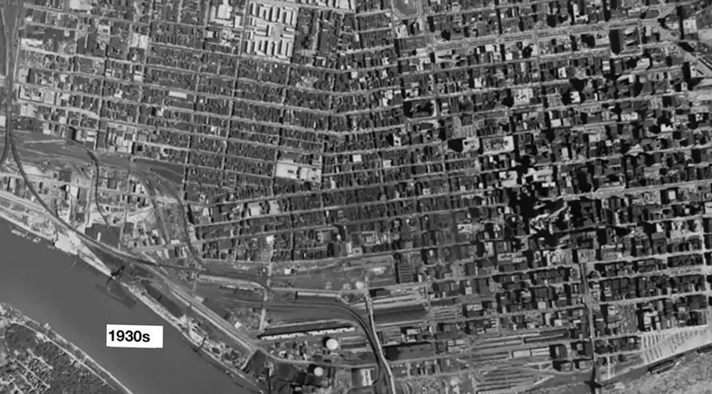

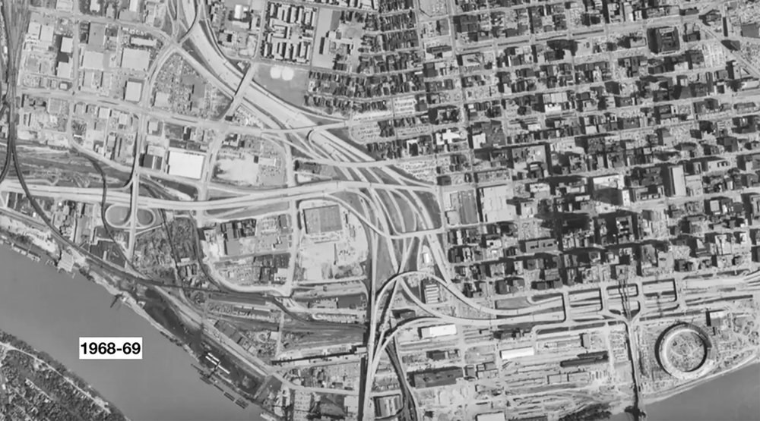

ODOT is required to take “affirmative action to remove or overcome the effects of the prior discriminatory practice” of constructing an interstate highway through a predominately Black community. We believe ODOT should investigate, through formal technical feasibility studies, narrowing the right of way and reconnecting city streets to reduce impact of the interstate highway through this neighborhood. This would facilitate the long-term rehabilitation of this community and bring the project in alignment with stated USDOT objectives of reconnecting communities that have been adversely impacted by prior infrastructure projects.
NEPA regulations require that an agency preparing an impact statement must “rigorously explore and objectively evaluate all reasonable alternatives which were eliminated from detailed study, and for alternatives which were eliminated from detailed study, briefly discuss the reasons for them having been eliminated” 40 C.F.R. § 1502.14(a). The stated purpose of this highway expansion project is to reduce congestion along the Brent Spence Corridor. Neither ODOT nor OKI discuss the use of tolling or congestion pricing in a no-build scenario in their consideration of alternatives to this project. While Kentucky state law prohibits the use of tolling to finance an expansion project of this type (“a development agreement or financial plan”), no regulation exists which would prohibit the use of tolling for congestion relief in a no-build scenario. Use of tolling as a financing mechanism was used in a similar project in Louisville, and the presence of tolling resulted in a significant decrease in traffic across a previously un-tolled river crossing. Evidence in the field of urban planning, including direct experience in the state of Kentucky, supports the use of congestion pricing or tolling as a “reasonable alternative” to highway widening for congestion relief, and no consideration of this alternative has been made in the development of the BSCP. The Federal Highway Administration Office of Operations promotes congestion pricing as a “way of harnessing the power of the market to reduce the waste associated with traffic congestion.” Arguments related to the political feasibility of congestion pricing should not be considered in the NEPA process, since the purpose of the environmental impact study is to allow the public to make informed decisions about the use of significant amounts of state and federal money – nearly three billion dollars in this case. If a reasonable alternative, such as congestion tolling on the existing infrastructure, is not rigorously explored and objectively evaluated, the public is unable to make an informed decision. ODOT’s NEPA submissions are therefore deficient on this basis.
The BSCP is currently advancing under an outdated Finding of No Significant Impact from FHWA, with a re-evaluation of this decision due to be completed in early 2023. The initial FONSI made no mention of issues related to air quality, and the adverse impact of highway expansion on air quality for minority and low-income communities directly adjacent to the Brent Spence Corridor has not been addressed in either the 2015 or 2018 environmental updates. ODOT applications reference an Air Quality Analysis from 2011, which states that the project would decrease emissions when compared to a no-build scenario. However, in 1000 Friends of Wisconsin v. United States Department of Transportation, USDOT apparently acknowledged that expanding highway access “will result in new vehicle trips and additional vehicle miles traveled and therefore cause some increase in harmful emissions.” Elsewhere, the decision states that USDOT has “acknowledged that induced travel will lead to higher emissions and somewhat lower air quality” and that “the impact statement [for the proposed widening of Wisconsin Highway 23] acknowledges that increased travel will lead to higher emissions.” ODOT and OKI estimate that the Brent Spence Corridor will carry 227,900 vehicles per day eighteen years from now, compared with around 165,000 vehicles per day under current conditions. In a 2015 interview, ODOT’s Brent Spence Corridor Project manager at the time stated that “the way Cincinnati is laid out, the more lanes you build on [Interstate] 75, the more traffic you draw . . . We could continue to build lanes on 75 but they would fill because of the nature of the traffic network in the region.” It is not clear how USDOT or ODOT reconcile these statements about air quality and induced travel with the referenced 2011 Air Quality Analysis, and there is no way of knowing whether any supposed reduction in emissions from decreased congestion after highway expansion is superior to the decrease that would be provided by congestion pricing because ODOT has not performed the relevant analysis.
The American Lung Association has noted the disparate impact of air pollution on low-income communities and communities of color, stating that
Many studies have looked at differences in the impact of air pollution on premature death. Recent studies have looked at the mortality in the Medicaid population and found that those who live in predominately black or African American communities suffered greater risk of premature death from particle pollution than those who live in communities that are predominately white.
A 2010 study commissioned by the City of Cincinnati noted that the adverse impact of air pollution related to traffic and construction along the I-75 corridor predominantly affects communities to the north and east, due to the prevailing wind patterns in the region. The West End community is situated directly to the north and east of the project area. The American Lung Association’s 2022 State of the Air Report named Cincinnati as the 12th most polluted metropolitan area for annual particle pollution. The FHWA should not provide a FONSI or other environmental approval unless ODOT and KYTC satisfactorily address concerns related to air quality, as air quality issues exist at the intersection of environmental and racial justice concerns. As noted above, ODOT and KYTC did not rigorously explore the alternative of congestion pricing, and the FHWA Division of Operations notes that
Three cities have implemented congestion pricing on a broad scale and have realized significant environmental benefits. Through cordon pricing in its central business district, London reduced emissions of particulate matter and nitrogen oxides by 12 percent and fossil fuel consumption and carbon dioxide emissions by 20 percent. Singapore's congestion pricing scheme prevents the emission of an estimated 175,000 lb of carbon dioxide each day; and Stockholm's congestion pricing system has led to a 10 to 14 percent drop in carbon dioxide emissions in its central area.
FHWA is required to identify and address these concerns about air quality and environmental justice, including exploring reasonable alternatives to highway expansion, under Executive Order 12898.
FHWA should not issue further environmental approval for this project unless ODOT and KYTC substantively address the civil rights and environmental justice concerns outlined in this letter. Steps to address these concerns would include:
- Formal technical consideration of design alternatives that take affirmative action towards remedying the ongoing disparate negative impacts of interstate highway construction through predominantly Black and low-income communities
- “Rigorous exploration and objective evaluation” of the use of congestion pricing or tolling as a “reasonable alternative” to highway expansion for congestion relief
- Analysis and mitigation of the adverse environmental impact of expanding interstate highway capacity through the cities of Cincinnati and Covington, which include but are not limited to concerns about air quality
Providing environmental approval for this project without doing so would violate Title VI of the Civil Rights Act of 1964, the NEPA process, its implementing regulations, and other federal civil rights and environmental justice requirements, including Executive Order 12898. We believe that the outdated Finding of No Significant Impact for this project should be rescinded, and no new environmental determination regarding the project should be issued, until these concerns are addressed.
We sincerely thank you for your attention to these concerns.

Respectfully submitted,

Ryan A. Crane, MD

Matt Butler
President
Devou Good Foundation

Reid Yearwood
Executive Director
Esperanza Latino Center of NKY

Joe Girandola
President
Art Academy of Cincinnati

Joe Humpert
President
Queen City Bike

Brewster Rhoads
Principal
Brewster Rhoads & Associates
Jody Robinson
President
Flourish Ventures

Sheryl Rajbhandari
Founder & Executive Director
Heartfelt Tidbits

Charles J. Kelly, MD, FAAP
Pediatric Care of KY

Beth Johnson
Executive Director
Cincinnati Preservation Association

Wade Johnston
Executive Director
Tri-State Trails

Rachel Hastings
Executive Director
Price Hill Will

Rev. Dr. Johannon R. Tate BS, MA, DMIN
Pastor
Jerriel Missionary Baptist Church

Tanner Yess
Co-Executive Director
Groundwork Ohio River Valley

Rev. Peter D’Angio
Rector
Trinity Episcopal Church

Nolan Nicaise
Commissioner
Covington, KY

David Hastings
Executive Director
Housing Opportunities of Northern Kentucky (HONK)

Margy Waller
Founder
Art on the Streets

Cal Cullen
Co-Founder and Executive Director
Wave Pool Corporation

Jim Guthrie
Principal
Hub + Weber Architects

As Individuals:

Barbara Didrichsen

Matthew Corbett
Chow-chi Huang

cc: Attorney Dennis M Grzezinski

1 President Joseph A. Biden, “Memorandum on Redressing Our Nation’s and the Federal Government’s History of Discriminatory Housing Practices and Policies”, January 26, 2021. Available at: https://www.whitehouse.gov/briefing-room/presidential-actions/2021/01/26/memorandum-on-redressingour-nations-and-the-federal-governments-history-of-discriminatory-housing-practices-and-policies/
In addition to other forms, discrimination based on national origin includes discrimination against persons with limited English proficiency (LEP) under Title VI. See, Improving Access to Services for People with Limited English Proficiency, 65 Fed. Reg. 159 (Aug. 16, 2000); see also Coldwell v. Dep’t of Health & Human Servs., 558 F.3d 1112 (9th Cir. 2009); United States v. Maricopa Cnty., 915 F. Supp. 2d 1073 (D. Ariz. 2012); Jones v. Gusman, 296 F.R.D. 416 (E.D. La. June 6, 2013); and Lau v. Nichols, 414 U.S. 563 (1974). See also, DOT Guidance on LEP, 70 Fed. Reg. 7408, 74095 (Wednesday, December 14, 2005).
January 26, 2021 Memorandum.
“Welcome to the FHWA Congestion Pricing Website.” Federal Highway Administration Office of Operations. https://ops.fhwa.dot.gov/congestionpricing/
1000 Friends of Wisconsin v. U.S. Department of Transportation, et al.. US District Court – Eastern District of Wisconsin. Case No 11-C-0545. https://1kfriends.org/wp-content/uploads/2015/05/decision-2015-05-22-1.pdf
“Brent Spence and 'companion' bridge could see 40% jump in traffic.” by Patricia Gallagher Newberry. Cincinnati Enquirer. August 29, 2022. https://www.cincinnati.com/story/news/traffic/2022/08/29/how-much-traffic-will-brent-spence-companion-bridge/65407695007/
“What will happen on the new Brent Spence when more traffic comes to I-75?” by Chris Wetterich. Cincinnati Business Courier. bizjournals.com/cincinnati/blog/2015/03/what-will-happen-on-the-new-brent-spence-when-more.html
“Disparities in the Impact of Air Pollution.” American Lung Association. https://www.lung.org/clean-air/outdoors/who-is-at-risk/disparities Last updated November 17, 2022. Accessed December 3,2022.
“Interstate 75 Focus Area Study Health Impact Assessment.” City of Cincinnati, December 2010. https://www.cincinnati-oh.gov/sites/health/assets/File/I75FocusAreaHIA.pdf Accessed December 3, 2020
“State of the Air 2022”. American Lung Association. https://www.lung.org/research/sota/city-rankings/msas/cincinnati-wilmington-maysville-oh-ky-in#pmann Accessed December 3, 2022.
“Congestion Pricing: Environmental Benefits.” Federal Highway Administration Division of Operations. https://ops.fhwa.dot.gov/congestionpricing/resources/enviro_benefits.htm Accessed December 6, 2022

